
ALPHACAM
VBA Router Example

The Project
In this project we are going to draw a door front with an arched panel from information supplied by the user and then machine the door complete. The project will contain a single form and two modules.

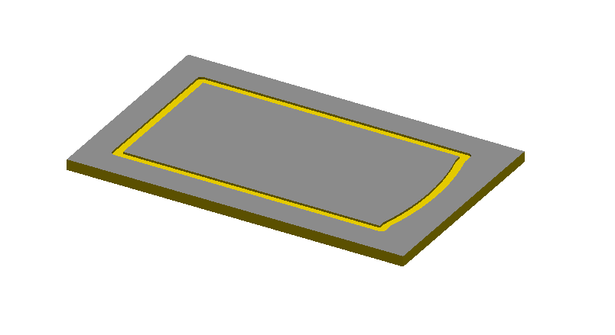Creating the New Project

Open a new VBA Project by selecting New VBA Project from the Add-Ins/Macros Tab. This will open the VBA editor and create a new empty project. Double click on the name property in the Properties Window and rename the project to CathedralDoor. From the File pull down menu select Save and save the project as CathedralDoor.arb in the following folder licomdir\VBMacros\StartUp\VBA Training.

Creating the Form
Insert a new form into your project by selecting the Insert pull down menu and clicking on UserForm.

The new form will need to contain the following controls
- 2 Frames
- 6 Text Boxes
- 6 Labels
- 2 Command Buttons

New controls are added to the form by single clicking on the desired control in the toolbox and then single clicking on the userform. If your toolbox is not visible it can be made visible by selecting Toolbox from the View pull down menu.

The form you are going to create will look like this
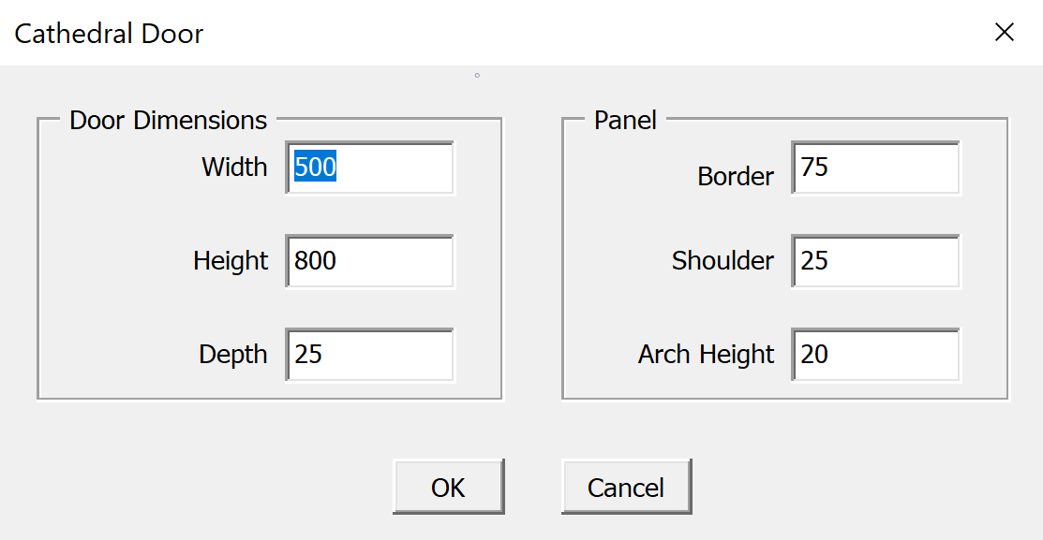

Set the caption property for each control as shown in the image above.

To make these new controls easy to identify it is best if they are given names that relate to what they are, and what you want to use them for. To set the name property for each control you single click on the control you wish to name in the UserForm window and then double click on the name property in the Properties Window. This will allow you easy access to each control at any time from within the project.

For this project we are going to use the name properties for the controls as follows

- Userform ~ frmMain
- Frame1 ~ fraDoor Frame2 ~ fraPanel
- Label1 ~ lblWidth Label4 ~ lblBorder
- Textbox1 ~ txtWidth Textbox4 ~ txtBorder
- Label2 ~ lblHeight Label5 ~ lblShoulder
- Textbox2 ~ txtHeight Textbox5 ~ txtShoulder
- Label3 ~ lblDepth Label6 ~ lblArch
- Textbox3 ~ txtDepth Textbox6 ~ txtArch
- Command1 ~ cmdOK Command2 ~ cmdCancel

It is quite likely that you will not have inserted the controls onto the form into a suitable order for moving around the form using the tab key on the keyboard. This can be changed by using the following procedure.

Set the Tab Order for the form by right clicking on the background of the form and selecting Tab Order from the pop up window.

fraDoor
fraPanel
cmdOK
cmdCancel

Set the Tab Order for the frame fraDoor by right clicking on the background of the frame and selecting Tab Order from the pop up window.

lblWidth
txtWidth
lblHeight
txtHeight
lblDepth
txtDepth

Set the Tab Order for the frame fraPanel by right clicking on the background of the frame and selecting Tab Order from the pop up window.

lblBorder
txtBorder
lblShoulder
txtShoulder
lblArch
txtArch

Writing the Code

The first thing we need to do is create a new menu so that we can run our project. To do this we need to insert a new module into the project. This is done by selecting the Insert pull down menu and clicking on Module. The module we are creating is special module because ALPHACAM needs to access it on initialisation to add a new menu. For this to happen the module has to have the name Events. To rename the module double click on the name property in the properties window and type in the word Events. In the code window for the Events module, we are going to add two new functions, one to add the new menu and one to show the userform when the new menu item is selected. The code is as follows:-

Public Function InitAlphacamAddIn(acamversion As Long) As Integer
Dim fr As Frame
Set fr = App.Frame
With fr
' set up itemname and menuname as new string variables
Dim ItemName As String, MenuName As String
ItemName = "Cathedral door": MenuName = "Standard Doors"
' create the new menu
.AddMenuItem2 ItemName, "ShowfrmMain", acamMenuNEW, MenuName
End With
InitAlphacamAddIn = 0
End Function

Function ShowFrmMain()
' show the main form
Load frmMain
frmMain.Show
End Function

To see the new menu you will need to save the project, then close and restart ALPHACAM. This will allow ALPHACAM to read your new module and add the new menu.

Select the new option and your form will be displayed.

At the moment there is no code associated with the form so the only way to exit the form is to select the ‘X’ in the top right corner of the form.

To continue editing the project we will need to reopen the project. Do this by selecting Open VBA Project from Add-in’s/Macros tab.

Each control on the form and the form itself can have its own unique piece of code. The easiest way to access the code for each control is by double clicking on the desired control in the Userform Window. This will open a new window called the Code Window and insert an empty subroutine based on the control’s default event.

We are going to set some default values for the form by using the form’s initialize event.

Double click on the background of the form in the Userform Window.

This will open the Code Window with the form’s default event, which is the click event as shown below.

Private Sub UserForm_Click()

End Sub

To change this to the initialize event there is a drop down box at the top right corner of the Code Window listing all the events available for the currently active control. Click on this and position your mouse over the word Initialize and then click again. This will create the following new code for you.

Private Sub UserForm_Initialize()

End Sub

Modify this new sub so that it looks like the following code

Private Sub UserForm_Initialize()
' set defaults for door
txtWidth = 500
txtHeight = 800
txtDepth = 25

' set defaults for panel
txtBorder = 75
txtShoulder = 25
txtArch = 20

' set focus to first text box and highlight
txtWidth.SetFocus
txtWidth.SelStart = 0
txtWidth.SelLength = 999
End Sub

Write the code for the click event for the command button cmdCancel so that it will end the project. The easiest way to create the new sub is to double click on the word frmMain in the Project Explorer Window. This will open the userform so that you can double click on the Cancel button on the form. This will create the following new code for you.

Private Sub cmdCancel_Click()

End Sub

Modify this new sub so that it looks like the following code

Private Sub cmdCancel_Click()
End ' end VBA macro
End Sub

To enable the Esc key on the keyboard to act in the same way as the cmdCancel button you can set the cancel property for the cmdCancel button to True.

Save the project and switch to ALPHACAM so that you can test the new code by selecting Cathedral Door from the Standard Doors menu.

To write the main code to draw and machine the door panel it would be possible to put all the code in the click event for the cmdOK button. The main problem with doing this is that in a large project it would become difficult to follow and debug the code. It would also mean that you may have to write the same piece of code more than once because a similar feature is required. To overcome this problem, it is best to create a new Module and write common functions into it. Calls to these functions can then be made from any point in the project.

Insert a new module into the project and set its name property to Main.

In this module we are going to write a new function to draw and machine the door. This can be achieved in two ways, either select Procedure from Insert menu or type the following code directly into the module.

Function CreateCathedralDoor()

End Function

This function will need to know the dimensions for the door as the user has typed them into the form. To do so, we edit the name of the function to include the variables we want to pass to it. This is shown below.

Function CreateCathedralDoor( _

Height As Double, Width As Double, Depth As Double, _

Border As Double, Shoulder As Double, Arch As Double)

End Function

To make a call to this function and send the required values to it edit the click event for the cmdOk button to hide the form and make a call to the function. The easiest way to create the new sub is to double click on the word frmMain in the Project Explorer Window. This will open the userform so that you can double click on the OK button on the form. This will create the following new code for you.

Private Sub cmdOK_Click()

End Sub

Modify this new sub so that it looks like the following code

Private Sub cmdOK_Click()
frmMain.Hide ' hide the form
DoEvents ' stop the project from processing until it has completed all previous tasks

' call the function to create the cathedral door
CreateCathedralDoor val(txtHeight), val(txtWidth), val(txtDepth), _
val(txtBorder), val(txtShoulder), val(txtArch)
End Sub
The following features will need to be edited into the CreateCathedralDoor function.

- Define the active drawing
- Create a work volume
- Create a material
- Draw the outside of the door
- Machine the outside of the door
- Draw the panel
- Machine the panel

Double click on the word Main in the Project Explorer Window to see the code for the module Main. Make the following edits to the CreateCathedralDoor function.

1. Defining the Active Drawing

' define the active drawing
Dim drw as Drawing
Set drw = App.ActiveDrawing

2. Creating the work volume

' create the work volume
Dim WorkVol As Path
Set WorkVol = drw.CreateRectangle(0, 0, Height, Width)
WorkVol.SetWorkVolume 0, -Depth

3. Creating the material

' create the material
Dim Material As Path
Set Material = drw.CreateRectangle(-1, -1, Height + 1, Width + 1)
Material.SetMaterial 0, -Depth

4. Creating the outside of the door

' create the outside of the door
Dim DoorGeo As Path
Set DoorGeo = drw.CreateRectangle(0, 0, Height, Width)
DoorGeo.ToolInOut = acamOUTSIDE

Switch to ALPHACAM and test the project by running it from the menu.
5. Machining the outside of the door

' machine the outside of the door
DoorGeo.Selected = True
Dim cut_door As Paths
Dim Tool As MillTool
On Error Resume Next ' ignore any errors
Set Tool = App.SelectTool(App.LicomdatPath & "licomdat\rtools.alp\Flat - 10mm.art")
On Error GoTo 0 ' cancel error ignore
' if the tool is not found show the normal tool select dialog box
If Tool Is Nothing Then
Set Tool = App.SelectTool("$User") ' allow the user to select a tool
End If
' create the machining data for the outside of the door
Dim cut_door_data As MillData
Set cut_door_data = App.CreateMillData
With cut_door_data
.FinalDepth = -Depth - 5
.MaterialTop = 0
.NumberOfCuts = 1
.OffsetNumber = 1
.RapidDownTo = 5
.SafeRapidLevel = 50
.Stock = 0
.XYCorners = acamCornersSTRAIGHT
Set cut_door = .RoughFinish
End With
' apply lead in and lead out
cut_door.Item(1).SetLeadInOutAuto acamLeadARC, acamLeadARC, 1.2, _
1.2, 90, False, False, 0

Switch to ALPHACAM and test the project by running it from the menu.

6. Creating the panel

' create the panel
Dim tempgeo As Geo2D
Dim PanelGeo As Path
Dim PanelxStart As Double, PanelyStart As Double
Dim PanelxFin As Double, PanelyFin As Double
PanelxStart = Border: PanelyStart = Border
PanelxFin = Height - Border - Arch: PanelyFin = Width - Border
Set tempgeo = drw.Create2DGeometry(PanelxStart, PanelyStart)
With tempgeo
.AddLine PanelxFin, PanelyStart
.AddLine PanelxFin, PanelyStart + Shoulder
.AddArc2Point PanelxFin + Arch, Width / 2, PanelxFin, PanelyFin - Shoulder
.AddLine PanelxFin, PanelyFin
.AddLine PanelxStart, PanelyFin
Set PanelGeo = .CloseAndFinishLine
End With
PanelGeo.ToolInOut = acamINSIDE
PanelGeo.SetStartPoint PanelxStart + ((PanelxFin - PanelxStart) / 2), PanelyStart

Switch to ALPHACAM and test the project by running it from the menu.

7. Machining the panel

' machine the panel
PanelGeo.Selected = True
Dim cut_panel As Paths
Set Tool = Nothing
On Error Resume Next ' ignore any errors
Set Tool = App.SelectTool(App.LicomdatPath &"licomdat\rtools.alp\Flat - 20mm.art")
On Error GoTo 0 ' cancel error ignore
' if the tool is not found show the normal tool select dialog box
If Tool Is Nothing Then
Set Tool = App.SelectTool("$User") ' allow the user to select a tool
End If
' create the machining data for the panel
Dim cut_panel_data As MillData
Set cut_panel_data = App.CreateMillData
With cut_panel_data
.FinalDepth = -5
.MaterialTop = 0
.NumberOfCuts = 1
.OffsetNumber = 1
.RapidDownTo = 5
.SafeRapidLevel = 50
.Stock = 0
.XYCorners = acamCornersSTRAIGHT
Set cut_panel = .RoughFinish
End With
' apply lead in and lead out
cut_panel.Item(1).SetLeadInOutAuto acamLeadLINE, acamLeadLINE, Tool.Diameter, _
Tool.Diameter, 0, True, True, 0

Switch to ALPHACAM and test the project by running it from the menu.
Add a new function to the module Main to check if the active drawing has any geometries in it. If it has, show a warning to allow the user to save any unsaved data if they want to.

Function FileNew()
' function to test if active drawing has any geometries
' and show a warning that any unsaved data will be lost
Dim MsgText As String
MsgText = "This will open a new drawing, press OK to continue"
Dim MsgBoxReturn As Integer
If App.ActiveDrawing.GetGeoCount > 0 Then
MsgBoxReturn = MsgBox(MsgText, vbOKCancel)
If MsgBoxReturn = vbOK Then
App.New
Else
End ' exit VBA macro
End If
End If
End Function

Modify the sub ShowFrmMain in the module Events to include a call to the new function.

Sub ShowFrmMain ()
' run function to test if the active drawing has any geometries
FileNew
' show main dialog box
Load frmMain
frmMain.Show
End Sub

Add a new function to the module Main to refresh the screen.

Function Refresh()
With App.ActiveDrawing
.ThreeDViews = True
.Options.ShowRapids = False
.Options.ShowTools = False
.Redraw
End With
End Function

Modify the sub ShowFrmMain in the module Events to include a call to the new function.

Sub ShowFrmMain()
' run function to test if the active drawing has any geometries
NewDrawing
' show main dialog box
Load frmMain
frmMain.Show
' run function to refresh the screen
Refresh
End Sub

